
Name: Abdul Samad
Program: BSSE Group A
Semester: 5th
Date: September 17, 2026
*-----------------------------------------------*

Lab Task 2
Program 1:

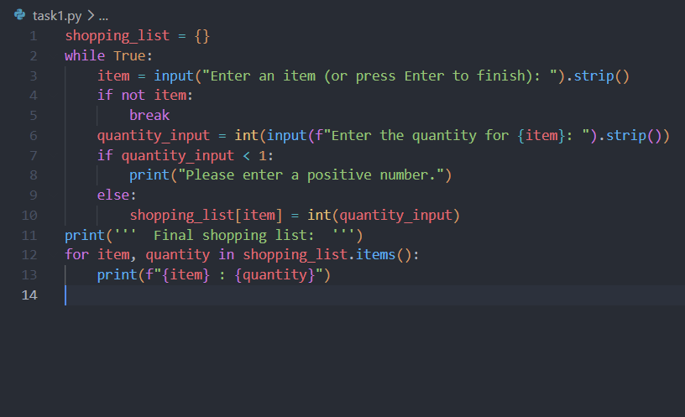

Output:
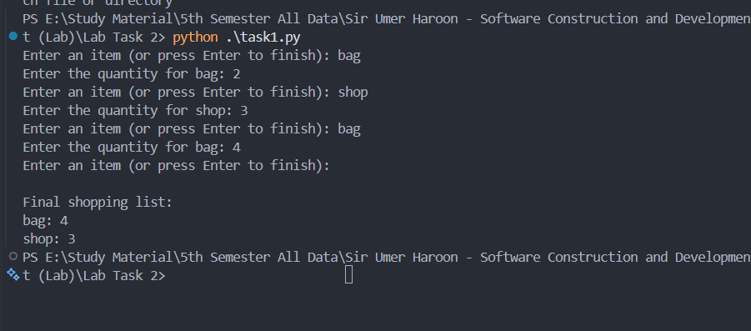
*-----------------------------------------------*
Program 2:
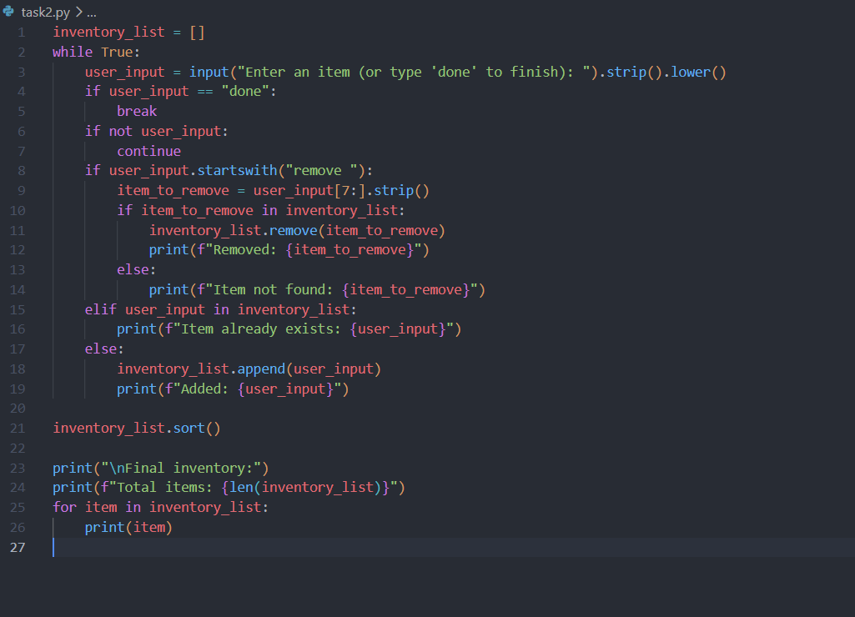
Output:
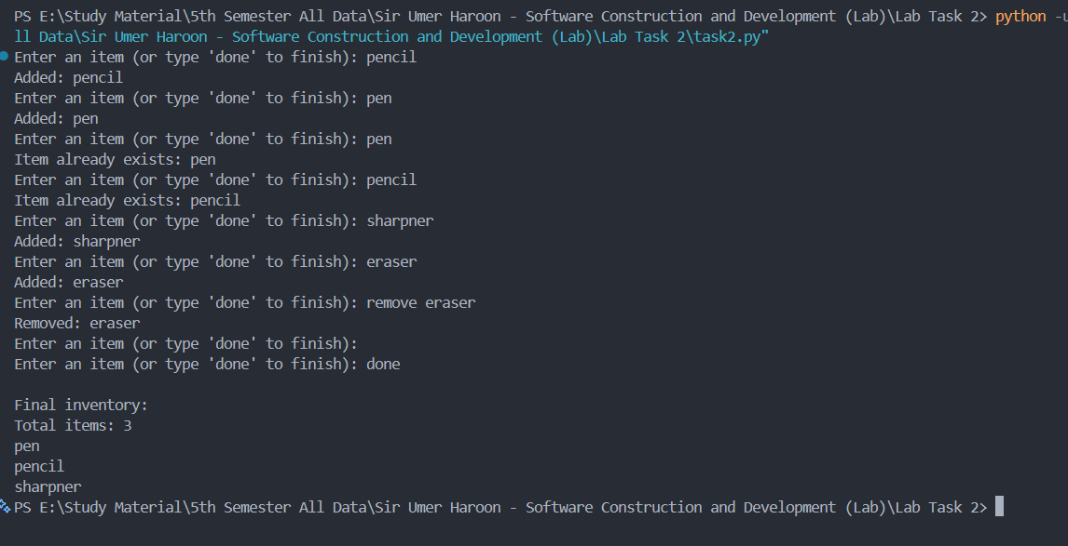
*-----------------------------------------------*

The End

